CZECH PRESIDENCY TEAM MEMBERS

Jiří Chalupa  Chairman of WG PROCIV  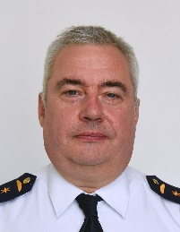  MoI - DG FRS CR  Kloknerova 26  148 01, Prague 414  Tel: +421 948 446 961  Mob: +420 603 360 225  jiri.chalupa@hzscr.cz |  | Roman Hlinovský  Vice - Chairman of WG PROCIV  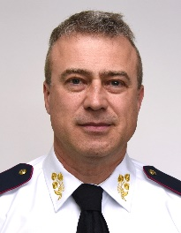  MoI - DG FRS CR  Kloknerova 26  148 01, Prague 414  Tel: +420 950 819 740  Mob: +420 724 185 582  roman.hlinovsky@hzscr.cz
Lenka Štiková  National delegate to WG PROCIV  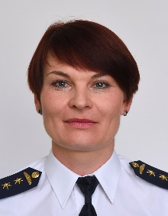  MoI - DG FRS CR  Kloknerova 26  148 01, Prague 414  Tel: +420 950 819 863  Mob: +420 724 193 402  lenka.stikova@hzscr.cz |  | Jakub Kufčák  National delegate alternate to WG PROCIV  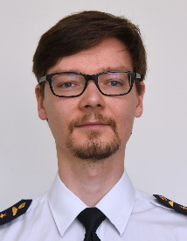  MoI - DG FRS CR  Kloknerova 26  148 01, Prague 414  Tel: +420 950 819 263  Mob: +420 603 323 031  jakub.kufcak@hzscr.cz
Nikola Dvořáková  Support WG PROCIV team  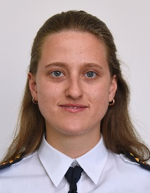  MoI - DG FRS CR  Kloknerova 26  148 01, Prague 414  Tel: +420 950 819 735  Mob: +420 771 227 537  nikola.dvorakova@hzscr.cz |  | David Schön  Responsible for Events Organisation  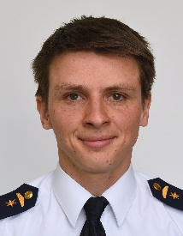  MoI - DG FRS CR  Kloknerova 26  148 01, Prague 414  Tel: +420 950 819 753  Mob: +420 778 761 123  david.schon@hzscr.cz
František Paulus  Subject matter expert of the CZ PRES priority  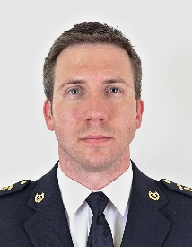  MoI - DG FRS CR  Population Protection Institute  Na Lužci 204  533 41, Lázně Bohdaneč  Tel: +420 950 580 220  Mob: +420 778 528 233  frantisek.paulus@ioolb.izscr.cz |  | Martin Pávek  Subject matter expert of the CZ PRES priority  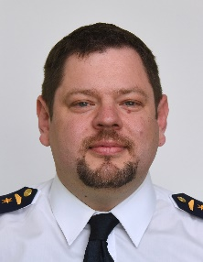  MoI - DG FRS CR  Kloknerova 26  148 01, Prague 414  Tel: +420 950 819 642  Mob: +420 725 169 247  martin.pavek@hzscr.cz

PROCIV CER TEAM

Daniel Dittrich  Chairman of WG PROCIV CER  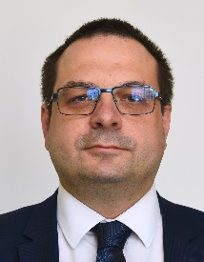  MoI - DG FRS CR  Kloknerova 26  148 01, Prague 414  Tel: +32 2 707 1732  Mob: +420 724 193 396  Mob: +32 470 09 32 03  daniel.dittrich@hzscr.cz |  | Barbora Pálková  Vice-chairman of WG PROCIV CER  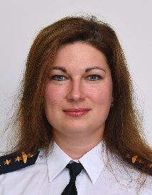  MoI - DG FRS CR  Kloknerova 26  148 01, Prague 414  Tel: +420 950 819 852  Mob: +420 778 547 803  barbora.palkova@hzscr.cz
Martin Tilcer  National delegate to WG PROCIV CER  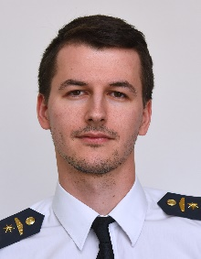  MoI - DG FRS CR  Kloknerova 26  148 01, Prague 414  Tel: +420 950 819 861  Mob: +420 773 075 449  martin.tilcer@hzscr.cz |  | Jakub Kufčák  National delegate alternate to WG PROCIV CER  MoI - DG FRS CR  Kloknerova 26  148 01, Prague 414  Tel: +420 950 819 263  Mob: +420 603 323 031  jakub.kufcak@hzscr.cz
David Patrman  Support WG PROCIV CER team  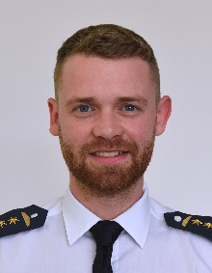  MoI - DG FRS CR  Kloknerova 26  148 01, Prague 414  Tel: +420 950 819 865  Mob: +420 732 163 573  david.patrman@hzscr.cz |  | Petra Bishtawi  Support WG PROCIV CER team  Ministry of Industry and Trade    Na Františku 32  110 15, Prague 1  Tel: +420 224 852 444  Mob: +420 724 180 028  bishtawi@mpo.cz
__________________________

