THE RISK ANYLYSIS FOR THE CZECH REPUBLIC
- FINAL REPORT -

Content:
- Reasons for the risk analysis processing
- Selected procedure solution
- Results of the risk analysis
- Conclusions

Annex

Processed by:
Mgr. et Mgr. František Paulus (Population Protection Institute Lázně Bohdaneč)
plk. Ing. Antonín Krömer (Fire Rescue Service, Moravian-Silesian Region)
kpt. Mgr. Jan Petr (Fire Rescue Service, Liberec Region)
plk. Ing. Jaroslav Černý (Fire Rescue Service, Olomouc Region)
based on partial sources processed and provided by ministries and relevant central administrative authorities within the activities of the working group ”Risk Analysis” of the Fire Rescue Service of the Czech Republic.

Prague 2015

THE REASONS FOR THE RISK ANALYSIS PROCESSING
The growing complexity of threats and risks arising from them affects directly or indirectly ensuring protection of the population and requires constant adaptation of capabilities of the components of the security system of the Czech Republic. Potential threats may be chained and their impacts on protected interests of the society may be mutually multiplied. With regard to the growing number of natural and manmade emergency events and severity of their consequences the targeted integrated approach to reducing the impact of these phenomena is becoming increasingly important. In the context of systematic application of the policy of prevention of emergency events and crisis situations the analysis of threats and risks arising from them is crucial.
In the Concept of Population Protection till 2020 with the outlook up to 2030, adopted by the Resolution of the Government of the Czech Republic N° 805 dated October 23rd 2013, the following task was established: “To Process the Risk Analysis for the Czech Republic and reflect its conclusions in the methodical and strategic materials in the field of national security (hereinafter the “task”). The deadline of the task was set till the end of 2016. The Ministry of Interior in cooperation with relevant ministries and other central administrative authorities is responsible for its implementation.
The task itself can be divided into two substantive parts. The first part includes the analysis in a broader meaning, which comprises the risks´ identification, risk analysis and subsequent evaluation. The risk impact level of these undesirable events is also determined. The subject of the second part is the implementation of obtained analytical outputs into the documents essential for ensuring the security of the Czech Republic.
The presented report is the final summary of the activities carried out within the first part of the task implementation. It introduces chosen methods and achieved results. The general basis of the subsequent stages of the task performance is mentioned above and beyond the submitted report.
In order to perform analytical activities, the working group within the authorized Ministry of Interior has been established comprising representatives of the Fire Rescue Service of the Czech Republic (hereinafter “FRS CR”). Representatives of relevant ministries and other central administrative authorities (Ministry of Interior – Department of Security Policy and Crime Prevention, Police Headquarters; Ministry of Finance; Ministry of Foreign Affairs; Ministry of Health; Ministry of Agriculture; Ministry of Justice; Ministry of Industry and Trade; Ministry of Regional Development; Ministry of Defence; Ministry of Environment; The State Material Reserves Administration; The National Security Office; The State Office for Nuclear Safety; The Czech Telecommunication Office) also significantly contributed to the resulting final form of the analysis.
The Report reflects the Decision of the European Parliament and the Council N°1313/2013/EU from 17th December 2013 on the Union Civil Protection Mechanism and thus reacts to the requirements imposed on the Member States in the area of prevention. By making information on the outcomes of the risk assessments available to the Commission of the European Union, the Czech Republic contributes to promoting an effective and coherent approach of the EU Member States in coping with large-scale emergency events and critical situations.

THE SELECTED SOLUTION PROCEDURE
The established task solution procedure respects relevant normative documents regulating the area of risk management and reflects the findings drawn from the experience with the threat analysis implementation in preparation for dealing with emergency events and crisis situations. The procedure is designed for the needs of the complex task implementation.
The chosen solution procedure involves the implementation of the key and cross-cutting activities:
- Key activities
  - project determination;
  - risk assessment (including identification of particular types of dangers; risk analysis; risk assessment);
  - risk treatment.
- Cross-cutting activities
  - communication and consultation;
  - monitoring and review.

The comprehensive task solution procedure is graphically represented in Figure N°1.

Figure N°1 The illustration of the chosen task solution procedure
The first part of the task
The second part of the task

PROJECT DETERMINATION
Identification of dangers (threats)
Risk analysis
RISK TREATMENT
COMMUNICATION
AND
CONSULTATION
MONITORING
AND
REVIEWING
RISK ASSESSMENT
Risk assessment
Key activities
Cross-cutting activities

Description of the key activities
- INTENT DETERMINATION
In accordance with the task assignment, the process of the risk analysis and arising risks is the purpose of the Czech Republic. The risks will be divided according to their importance and the types of danger for which the type plan will be processed.
The terms used in the Report are applied in many other areas and therefore in their classifying not all branch specifics can be taken into account. The terminology discussion is not the subject of the report. Therefore the used terms are for the need of the task solution specified in the following way:
- Danger
Danger is any event which is able to damage protected interests. It is the substance property or physical situation (state, circumstance) which has the potential to cause loss of lives and damage human health, environment or property.
- Protected interests
Protected interests are lives and health of people, property, environment and economic and social stability.
- Threat
Threat is a synonymous expression of the term of danger. The term is particularly used in relation to serious dangers capable to harm the interests of the Czech Republic.
- Risk
Risk is the probability of formation of an undesirable specific effect occurring within a certain period of time or under certain circumstances and which is considered as undesirable from the security point of view. Risk is always associated with a particular type of danger.

- RISK ASSESSMENT
Risk assessment is the key activity for the solution of the first part of the task. The process consists of the following partial activities:
  - identification of dangers (threats);
  - risk analysis;
  - risk assessment.

Identification of dangers (threats)
In the terms of identification the members of the FRS workgroup and the representatives of concerned ministries and other central administrative authorities carried out the specification of particular types of danger and established the unified register. The authorized ministry or other central administrative authority or potential co-coordinators have been established for each identified type of danger. The identified types of danger have been distinguished with respect to the following categories:
- naturogenic (abiotic / biotic / cosmic);
- anthropogenic (technogenic / sociogenic / economic).

Risk analysis
The risk analysis has been processed for identified types of danger. The output is the risk level determination – quantities expressing, that with a certain probability a particular type of danger will be realized and its destructive potential will be applied. The risk is given by the product of probability and consequences.
For procedure optimising the risk analysis was carried out in two steps. As the first step, all types of danger registered in the registry were selected through the preliminary analysis. The output of the activity was the division of all types of danger into two groups, namely into dangers with a low risk and dangers with a high risk. The types of danger belonging to the group of a low risk are received as acceptable and there is no need to subject them to further investigation. In the justified cases an authorized ministry or other central administrative authority could decide in case of danger with a low risk to carry out the second step of the analysis.
As the second step the detailed multi-criteria analysis of all types of dangers belonging to the group with a high risk was carried out and particular risk levels were determined. Probability and consequences have been evaluated in the ten-point semi-quantitative scales, and the consequences as an aggregated quantity took into account partial effects on lives and health of people, environment, economy and society.
More detailed information about the preliminary and detailed multi-criteria risk analysis is mentioned in the Annex N°1.

Risk evaluation
The purpose of the evaluation is to identify priority risks which need our attention. With respect to the necessity of differentiation of taken measures, the members of the FRS workgroup determined limited risk values (the lowest risk limit is 10, the highest risk limit is 30), under which three basic risk categories were distinguished:
- acceptable risks (risk level 0 – 10);
- conditionally acceptable risks (risk level 11 – 29);
- unacceptable risks (risk level 30 and more).

- RISK TREATMENT
The implementation of the risk treatment process belongs to the second part of the task. The purpose is to implement the outcomes of analytical findings into the key materials ensuring the national security and to support their practical realisation.

Description of cross-cutting activities
- COMMUNICATION AND CONSULTATION
The process requires close cooperation of involved actors, namely in this case the members of the FRS working group and the representatives of concerned ministries and other central administrative authorities. For this purpose special seminars and workshops on a bilateral level were organised.
The intention of the task processing and its solution framework process were also discussed with the Secretaries of the Regional Security Councils.

- MONITORING AND REVIEW
The whole process will be periodically renewed and the identified types of danger will be revised according to the current security situation. The used method will also be revised and possibly modified. The proposed periodicity of the repetition process is related to the next concept of population protection.

3. THE RISK ANALYSiS RESULTS
In accordance with the established task solution procedure the members of the FRS working group and the representatives of concerned ministries and other central administrative authorities initially identified 72 types of danger and, based on specified categories, established their register. Anthropogenic dangers constituted 54% share and naturogenic dangers 46% share.
Subsequently the risks were analysed. During preliminary analysis 21 types of danger were identified as a low risk and they were not subjected to further investigation. Of the total number of identified dangers 49 types were comprehensively analysed. The remaining two types of danger (intrusion of information security of the critical information infrastructure, large-scale intrusion of financial and foreign exchange state economy) were without previous analysis indicated as a danger of a high risk level and assessed as unacceptable risks. The reason is that the conditions stipulated by the legal instruments predict in these situations declaration of the crisis state.
The share of particular categories in the total number of dangers subjected to the detailed multi-criteria analysis is graphically represented in Figure N°2.

Figure N°2 The share of categories of danger in the total number of dangers subjected to the detailed analysis
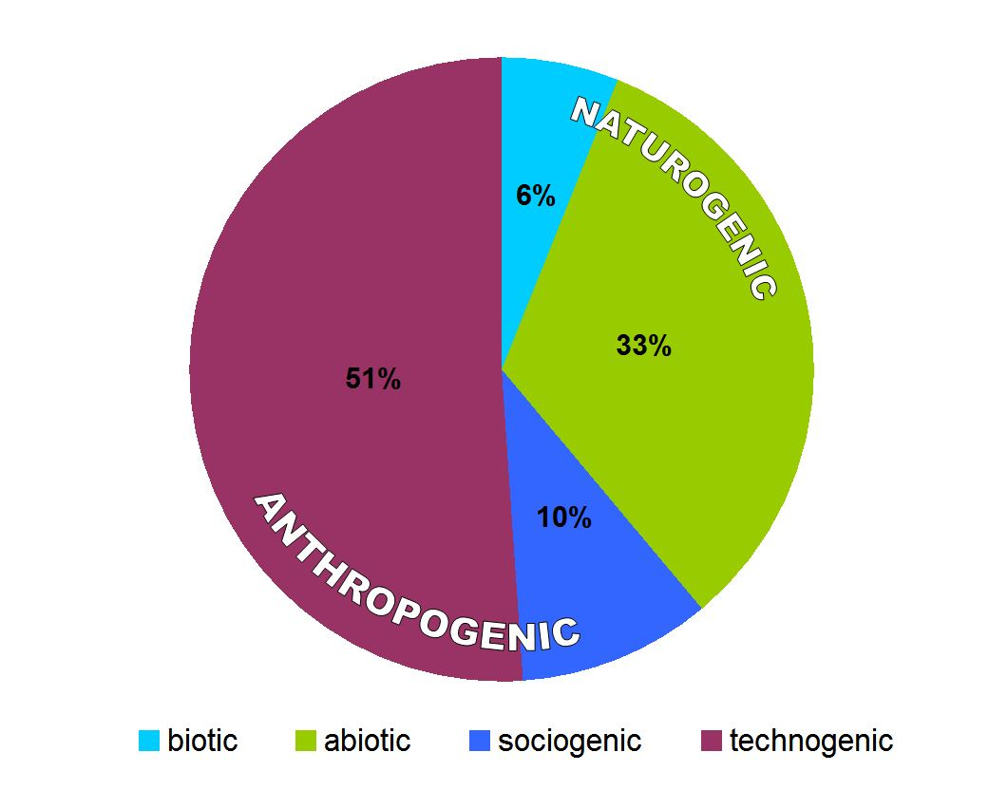

The risks arising from particular dangers were analysed in detail and subsequently assessed in the terms of their significance. Of the total number of evaluated figures, the proportion of individual categories was as follows:
- acceptable risks - 4 %;
- conditionally acceptable risks - 53 %;
- unacceptable risks - 43 %.

Acceptable risks, is the category for which the adoption of emergency measures is not expected. Usually the situations are manageable under the regime of current activities of the Integrated Rescue System Services and relevant administrative authorities. Due to the low risk level, the dangers eliminated from preliminary analysis can be included into this category.
Conditionally acceptable risks already require adoption of measures leading to their elimination. This category belongs to the field of preparation for dealing with emergency events and mainly includes emergency planning and preparation of the type activities of the Integrated Rescue System Services.
Unacceptable risks constitute the category which requires the highest priority of all levels of public administration. The measures leading to their elimination fall into the field of preparation for dealing with crisis situations and mainly include crisis planning.
Graphical representation of the risk assessment arising from particular dangers subjected to the detailed multi-criteria analysis is presented in Figure N°3.

Figure N 3 The results of the analysis and risk assessment
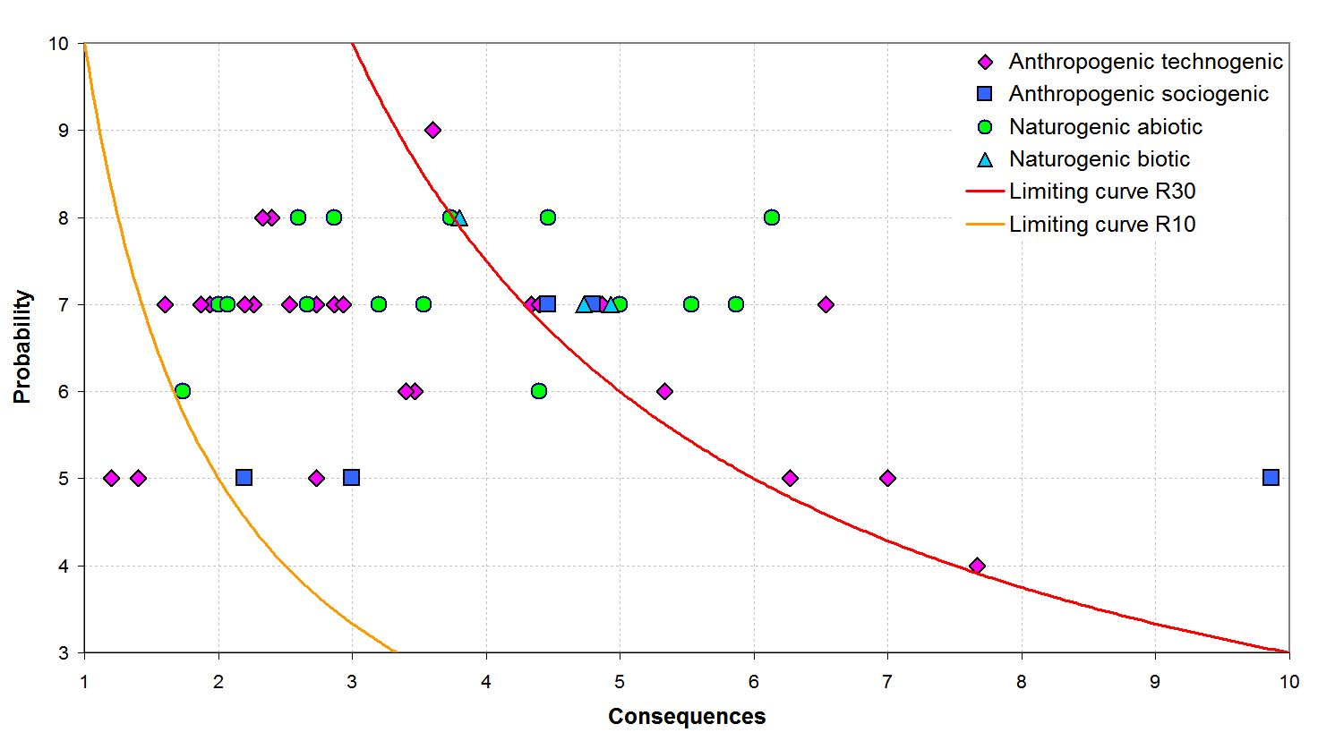

Based on the carried out evaluation 21 types of dangers of unacceptable risk requiring priority attention, were identified. However the military attack on the Czech Republic, as one of the threats included in this category, was removed from the further process in the view of the fact that the comprehensive independent system of planning and preparedness provision were developed for this area. On the contrary, the threat of security breaches of the critical information infrastructure and the threat of breaches of the financial and foreign exchange economy of the state of a large-scale were included in the category of dangers with unacceptable risk without previous analysis for the reasons mentioned above in the final part of this report. It is also necessary to emphasize that lately often mentioned threat of terrorism presented as a “large-scale violation of legality” is presented as a comprehensive threat to the problems of internal security and public order except the issue of migration.
In total, 22 types of danger have been identified for the Czech Republic, for which the crisis state can reasonably be announced. For these cases, it is necessary to take measures to eliminate their risks and develop a new generation of the type plans within the system of crisis planning.
The processors (processing administrators) are concerned ministries and other central administrative authorities. Other ministries and other central administrative authorities and also the Czech National Bank will participate in the type plan processing as co-administrators.
In the terms of adopting measures leading to elimination, dangers will be divided according to the levels of management in the following categories:
- central;
- regional;
- central and regional.
The table N°1 provides the overview of 22 identified types of danger with unacceptable risk.
Table N°1 The types of danger with unacceptable risk
CATEGORIES OF DANGER |  | TYPES OF DANGER WITH UNACCEPTABLE RISK | RESPONSIBILITY*
naturogenic | abiotic | Long term drought | MoE, MoA, MoI
naturogenic | abiotic | Extremely high temperatures | MoE
naturogenic | abiotic | Flash flood | MoE, MoI, MoA
naturogenic | abiotic | Heavy rainfall | MoE, MoI
naturogenic | abiotic | Extreme wind | MoE, MoI
naturogenic | abiotic | Flood | MoE, MoI, MoA
naturogenic | biotic | Epidemics – mass infection of people | MoH
naturogenic | biotic | Epiphytic – mass infection of field plants | MoA
naturogenic | biotic | Epizootic – mass infection of animals | MoA
anthropogenic | technogenic | Huge food supply disturbance | MoA, MoIaT
anthropogenic | technogenic | Functioning disturbance of significant electronical communication systems | CTO, MoIaT
anthropogenic | technogenic | Information security disturbance of critical information infrastructure** | NSO, MoI
anthropogenic | technogenic | Special flood | MoA, MoI, MoE
anthropogenic | technogenic | Dangerous chemical substance leakage from the stationary premise | MoE, MoI, SOfNS
anthropogenic | technogenic | Huge drinkable water supply disturbance | MoA
anthropogenic | technogenic | Huge gas supply disturbance | MoIaT, MoI
anthropogenic | technogenic | Huge oil and oil products supply disturbance | AoSMR, MoIaT
anthropogenic | technogenic | Radiation accident | SOfNS, MoI
anthropogenic | technogenic | Huge electric energy supply disturbance | MoIaT, MoI
anthropogenic | sociogenic | Huge migration wave | MoI, MoFA
anthropogenic | sociogenic | Huge legitimacy disturbance (including terrorism) | MoI
anthropogenic | economic | Huge national financial and exchange state economy disturbance** | MoF, CNB
* Responsible ministries and other central administrative authorities and the CNB are given in bold letters.
** Inclusion of the type of danger into the category of danger with unacceptable risk is based on the fact that legal conditions presume for these situations the declaration of the crisis state.

The summary registry of dangers with the risk analysis results is provided in the Annex N°2.

4. CONCLUSION
Ensuring protection of lives and health of people, environment and property values is one of the fundamental obligations of the state. The ability to develop preventive measures, such as the threat analysis and risks arising from them in respect of emergency events and crisis situations threatening the protected interests of the society, is the fundamental prerequisite for fulfilling this obligation.
In accordance with the task assignment resulting from the Concept of Population Protection till 2020 with the outlook up to 2030 and taking into account the decision of the European Parliament and of the Council N° 1313/2013 / EU from 17th December 2013 on the Union Civil Protection Mechanism the submitted report summarizes the findings of the analysis of threats and risks arising from them for the Czech Republic.
72 types of dangers were identified at the national level, 22 of them were identified as the dangers of unacceptable risk, which need the priority attention at individual levels of public administration. These are the situations, the Czech Republic has real experience with but also the situations that have not happened yet in our environment, but due to the risk level it is still necessary to take measures to eliminate them (e.g. huge legitimacy disturbance within which the issue of terrorism is contained).
The outputs described in the submitted report will form, after consulting them with the Government of the Czech Republic, the basis for realisation of the second part of the solved task. Within the activities associated with the risk treatment the new methodology and the structure of the type plans of dangers with unacceptable risk will be developed.
In comparison with the current approach to the type plans processing, the fact, that for some dangers it is optimal to take measures eliminating risks at the level of relevant ministries and other central administrative authorities and for others at the regional level, will be respected. Besides the above mentioned categories the dangers requiring taking measures to eliminate risks will be differentiated at all levels of public administration.
For the need of regional risk analysis, the process realised within the national analysis and generally described in the submitted report during 2016 will be developed through the implementation of methodological tools.

ANNEX
Annex N°1 – Risk Analysis Execution
Annex N°2 – Register of Dangers with the Risk Analysis Results

